
https://atlas.cid.harvard.edu/

Optimal Industry Development Strategy Using Economic and Product Complexity

Denmark

─
The Economic Complexity Lab - Columbia University
Alexandra Garcia, Kelly Mi, Margarita Demkina, Allison Lin, Helena Yang, Jane Zhang, Daniel Xu, Ryo Shibata, Haoxian Chen, Davepriyan Gunaratnam, Rohan Macherla, Ajit Akole, Shomik Ghose, Alex Wei-Liang Ku, Sannidhya Modi, Xilin Wang

Optimal Industry Development Strategy for Denmark

0. Executive Summary

In this report, we aim to uncover the economic path Denmark went through during the period from 2013 to 2021. Specifically, we dive into the topic through a macroeconomic overview of Denmark from the perspective of Gross Domestic Product (GDP) and Economic Complexity Index (ECI), which reflect countries’ production capability and production structure, respectively. We find that during the period of our interest, Denmark demonstrated a moderate level of economic growth with an average annual GDP growth rate of 3.57% between 2013 and 2018 and 4.66% between 2019 and 2021, concurrent with a decrease in economic complexity as compared with other major developed economies.

The lack of progress during the period, we believe, can be partially explained through analysis of the economic and product complexity structure of Denmark on the industry group level. The product classification system we adopt allows us to measure the realized industry development for various industry groups and to observe that Denmark consistently relied on developing the Food and Preparations, Wood Products, and Chemicals industries in 2013-2018 and High-complexity products and Chemical Manufacturing in 2019-2021.

Based on our analysis of the opportunity gain and a sensitivity analysis of major industry groups, Denmark could have furthered its gains by prioritizing High-Complexity Products and Transportation in 2018. Three years later, in 2021, its focus again should have been aligned to Transportation, which is consistently underdeveloped. We further note that Denmark has a slightly mismatched development strategy that indicates an average (compared to other developed economies) level of structural optimality on the complexity level, having an adjusted R-square of around 4.8% in 2018 and a lower score of 2.4% in 2021, demonstrating degradation in development. Since a significant positive correlation exists between five-year GDP growth and the structural optimality index of an economy as we define and calculate, Denmark indeed has a suboptimal growth experience as compared with fast-growing economies both on a regional scale and on a global scale, and has the potential to further its economic gains through industrial structure optimization as suggested in the paper.

The three years following showed a significant improvement in Denmark’s economic growth, boosting its position on the global scale. Although its GDP did not drop significantly during the pandemic, its ECI fell, similar to its peer countries. Its current strategy still has the viable potential, however, we recommend the following to increase its performance and optimize its structure further.
1. Report Overview

In this report, we aim to uncover the economic path Denmark went through during the period from 2019 to 2021, before and after the COVID pandemic, compared to its performance from 2013 to 2018, before and after the COVID-19 pandemic. Specifically, we dive into the topic through a macroeconomic overview of Denmark from the perspective of Gross Domestic Product (GDP) and Economic Complexity Index (ECI), which reflect countries’ production capability and production structure, respectively. We then analyze the industrial framework and changes of Denmark during the period based on quantitative measures such as Product Complexity Index (PCI) and Product Family Complexity Index (PfCI), followed by a detailed analysis of how such changes have matched with development strategies as quantitatively measured by opportunity gains on an industry-level. We conclude our report with macro-level results and predictions of Denmark, as deduced from regression models we have established on a global scale, which take into account countries’ stances in their product space.

2. Macroeconomic Results

2.1 GDP Ranking and Changes
Figure 1a illustrates the time-series GDP results for Denmark and three of its peer countries (Norway, Sweden, Finland) from 2013-2018. Denmark displays consistent, upward growth over the period, which is similar to Finland and Sweden, but different from the volatile, up-and-down GDP growth of Norway. Denmark stands out as it leads in average annual GDP growth rate among its peers; its AAGR of 3.57% is clearly above that of Norway (0.54%), Sweden (3.44%), and Finland (2.84%).

Figure 1b shows the GDP levels for Denmark and the same peer countries from 2019 to 2021. Similar to the other countries, Denmark’s GDP was largely unaffected by the pandemic in 2020 while experiencing growth in the aftermath. Over these three years, Denmark's average annual GDP growth rate (4.66%) is slightly lower than others, such as Norway (7.55%) and Sweden (5.77%) but higher than Finland (3.76%).

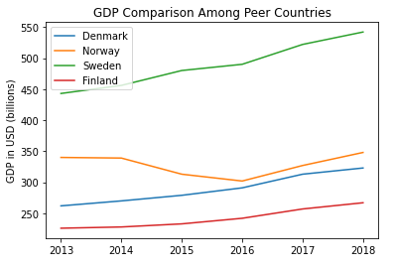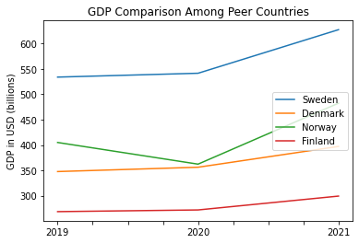

Figures 1a and 1b. GDP Comparison Among Peer Countries (left: 2013-2018; right: 2019-2021)

2.2 ECI Ranking and Changes
The Economic Complexity Index (ECI), as defined by Ricardo Hausmann and Cesar Hidalgo in 2009 to explain the knowledge accumulated in a country's population, is illustrated in Figures 2a and 2b.

As shown, Denmark exhibits a small decrease in production capability from 2013 to 2018. However, this decrease (-9.25%) is noticeably lower than that of Norway (-351.33%), Sweden (-33.82%), and Finland (-15.68%). Denmark clearly shows strong economic fundamentals over the period, as it has the highest GDP growth rate and highest ECI percent change compared to its peers.

The comparable countries maintained a small change in ECI level between 2019 and 2020, with a sharp change between 2020 and 2021. Denmark exhibits a large decline in production capability in 2021 to levels not seen prior, with disruptions due to the pandemic being the primary reason. Denmark has seen a -175% decrease in its ECI, which is a milder decrease than Sweden (-209%) and Finland (-267%) but smaller than Norway’s increase (153%).

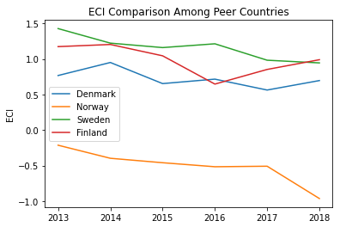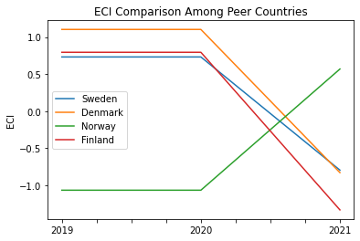
Figures 2a and 2b. ECI Comparison Among Peer Countries (left: 2013-2018; right: 2019-2021)

Figure 3a and 3b offers a further comparison of GDP Growth and ECI over the time span from 2013 to 2021 for Denmark. The steady increase in GDP growth during the period from 2013 to 2018 is accompanied by a volatile eventual decrease in ECI (though ECI seems to rebound near the end of the period). Similarly, between 2019-2021, the decrease in ECI is accompanied by steady increases in GDP. The results show that the economic growth experienced by Denmark during the period from 2013 to 2018 is not very consistent with the predictions by ECI (the most egregious contrast can be seen by the fact that 2016-17 had the highest GDP growth rate but had a sharp ECI decrease) and that Denmark had not yet effectively developed a competitive product space that helps to accumulate complicated knowledge and technology. In order to provide a more concrete answer to why this has happened, we will dive into an analysis of Denmark’s production structure and its product space designs in the next few chapters.
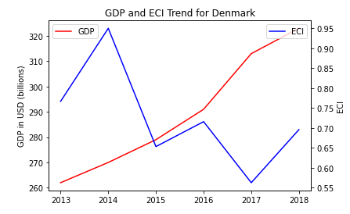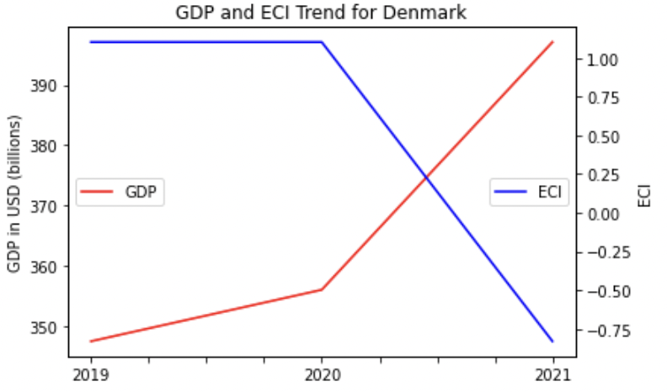
Figures 3a and 3b. GDP Growth and ECI for Denmark (left: 2013-2018; right: 2019-2021)
3. Production Analysis

3.1 Product Categorization
Our main data source in this research is the UN Comtrade Website (https://comtrade.un.org), which provides us with valuable information on countries’ export values on an annual basis, including highly specific export data for more than 5000 categories of products. In order to have a holistic vision of the product space of a country, however, a level of categorization is required. Products in our data source are labelled from 010000-999999, with the first two-digits representing a general category to which the product belongs. Based on the 99 categories as extracted from the label, we further group the products into 18 most widely-accepted industries, as summarized in Table 1.

Note that the High-complexity Products industry group is not a distinct industry but rather an aggregated industry that encompasses the most complicated products from the most technologically-advanced industries (as measured by PCI). This industry serves as an indicator for us to quantitatively evaluate how well a country has performed in developing cutting-edge technologies and closing its technical gap with advanced economies, which has become a topic of wide concern today. Indeed, when we rank the 18 categories based on PfCI (an equivalent concept of PCI as calculated based on the 18 categorized product groups), the High-complexity Products industry has the highest PfCI among all industry groups.

Category | Description
Animals and By-products | All kinds of meat, livestock and related by-products
Vegetables, Fruits and Plants | All kinds of plants, edible vegetables and fruits
Food and Preparations | Edible preparations, raw cooking materials and appliances
Clothing and Accessories | All kinds of fabrics, filament, clothing and accessories
Textiles | All kinds of textile articles and related products
Wood Products | Book, paper and other elementary products related to wood
Metals | Mining of all sorts of raw Metals
Refined and Processed Stones | Refined or processed stone products such as pearl and ceramics
Energy Drilling and Mining | Mining industry for energy, minerals, stone materials, etc.
Daily Instruments | Basic daily instruments such as sport requisites, timing and measuring tools
Raw Manufacturing | Basic products made from plastic, rubber, leather, etc.
Chemical Manufacturing | Advanced chemical products and pharmaceutical products
Chemicals | Raw chemical materials and by-products
Machinery and Construction | Machinery and mechanical appliances, including electrical equipment
Transportation | Vehicles and locomotives including aircraft, ship, railway, etc.
Weapons | Explosives, arms and ammunition
Services and Utilities | Financial, business, legal, communication, travel Services and Utilities, etc.
High-complexity Products | Agglomeration of advanced products with highest PCIs

Table 1: Categorization of Products

We further observe a positive correlation between the GDP and the export of High-complexity Products. A higher adjusted R-square exists between GDP and High-complexity Products exports, indicating that more successful economics, as measured by GDP, tend to be those that are capable of producing and exporting High-complexity Products as we define them. The Figure 3 and 4 show the OLS results in a universe of 107 and 21 typical countries respectively.
 | High-complexity Products | Food and Preparations | Animals and By-products
Adj.R-squared | 0.075 | 0.006 | 0.002
F-statistic | 9.556 | 1.638 | 1.175
No. Observations | 107 | 107 | 107

Figure 3: OLS Regression Results of GDP against Percentage Volume of Exports

 | High-complexity Products | Food and Preparations | Animals and By-products
Adj.R-squared | 0.149 | 0.003 | -0.012
F-statistic | 4.510 | 1.059 | 0.7542
No. Observations | 21 | 21 | 21

Figure 4: OLS Regression Results of GDP against Volume of Percentage Exports

3.2 Realized Industry Development
Based on the product categorization aforementioned, we aim to capture Denmark’s realized industry production strategy between 2013 and 2021 on a complexity level. In Hausmann and Hidalgo (2009), distance is defined to be a measure of how far a country is from a certain product not in its product space. We extend this concept to all product groups and quantify how technically equipped a country is to develop the corresponding product groups. In other words, the shorter the distance between a country and a product group, the more capable a country is in developing products within that group. Defining this net distance change as the Realized Industry Development (RID), our export data allow us to calculate and compare RID of US and the 18 product groups in 2021 and 2018 through the difference, where a positive RID indicates a shortening of the distance (i.e., advancement of the industry), and a negative RID indicates the reverse. It is notable that the number of industries with positive RID has decreased from 18 to 3 between 2018 and 2021.

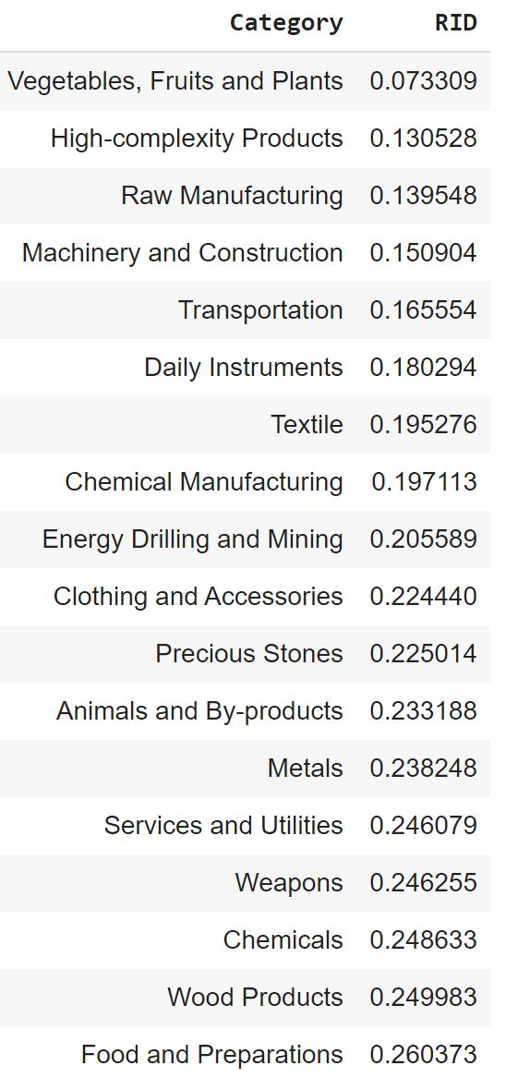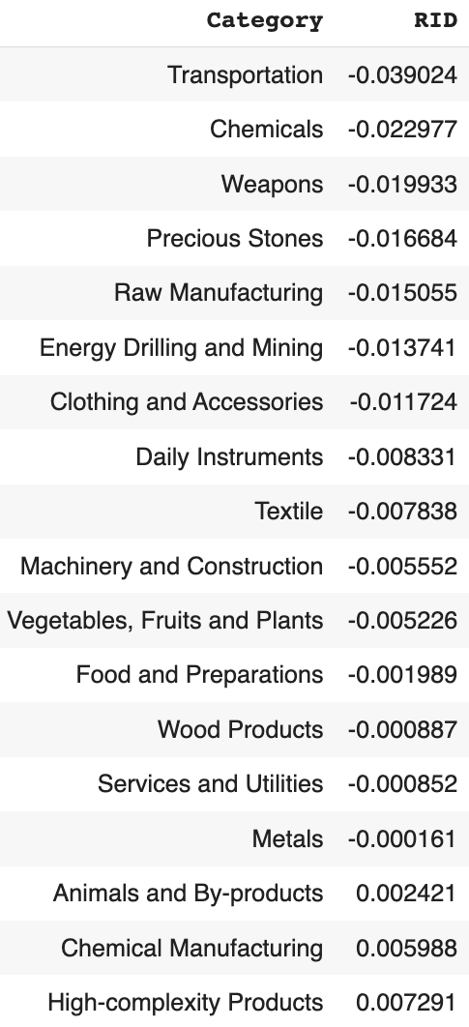
Table 3. Realized Industry Development (RID) of Denmark (2018 on left, 2021 on right)
3.3 Regional and Global Comparison
Tables 4a-4b below summarize how the production strategy adopted by Denmark compares with selected leading economies in the world across different years, as measured in RID. Leading economies such as France, the United States and Germany gave a considerable level of attention to more advanced product groups such as Weapons and High-Complexity Products in 2018 and Services and Utilities, Precious Stones, and High-Complexity Products in 2021.

Ranking | France | the UK | Germany
1 | High-complexity Products | Services and Utilities | High-complexity Products
2 | Chemical Manufacturing | Weapons | Transportation
3 | Daily Instruments | Raw Manufacturing | Wood Products
4 | Animals and By-products | Precious Stones | Metals
5 | Food and Preparations | Animals and By-products | Food and Preparations
Table 4a. RID Comparison across Leading Economies (2018)

Ranking | France | the UK | Germany
1 | Services and Utilities | Precious Stones | Daily Instruments
2 | Precious Stones | High-complexity Products | Transportation
3 | High-complexity Products | Services and Utilities | Chemicals
4 | Energy Drilling and Mining | Energy Drilling and Mining | Chemical Manufacturing
5 | Machinery and Construction | Wood Products | Clothing and Accessories
Table 4b. RID Comparison across Leading Economies (2021)

Tables 4c-4d further examine Denmark’s development strategy against those of emerging economies on a global scale. Reasonably, emerging economies such as China, South Korea, and Singapore, have devoted the majority of their efforts to intermediate industry groups, showing drastic shifts in strategies over the course of three years.

Ranking | China | South Korea | Singapore
1 | High-complexity Products | Transportation | Transportation
2 | Transportation | Textile | High-complexity Products
3 | Machinery and Construction | High-complexity Products | Precious Stones
4 | Energy Drilling and Mining | Chemical Manufacturing | Daily Instruments
5 | Daily Instruments | Machinery and Construction | Services and Utilities
Table 4c. RID Comparison across Emerging Economies (2018)

Ranking | China | South Korea | Singapore
1 | Chemicals | Chemicals | Weapons
2 | Daily Instruments | Daily Instruments | Energy Drilling and Mining
3 | Transportation | Transportation | Transportation
4 | Raw Manufacturing | Textile | Machinery and Construction
5 | Weapons | Raw Manufacturing | High-complexity Products
Table 4d. RID Comparison across Emerging Economies (2021)

4. Product Space Design

4.1 Suggested Development Vector
As aforementioned, distance gives us an idea of how far each new product is from a country’s current mix of exports. As defined in Hausmann and Hidalgo (2009), distance is “the weighted proportion of products connected to goods p that country c is not exporting, i.e., MCP=0.” Based on this definition, the distance between a country and any product that the country is currently exporting (i.e., the country is a significant exporter in the product as compared to global average) is zero. Similarly, opportunity gain quantifies the contribution of a new product in terms of opening up the doors to more and more complex products. Intuitively, a product that a country is currently exporting (i.e., MCP=1) has an opportunity gain of zero. And unreasonable investment on certain product p would lead to a relative decrement in export of more profitable products, and therefore lead to a negative opportunity gain of product p. The opportunity gain is not the only estimator of a country’s level of economic development. However, among countries with comparable economics strength, those having higher ECI, or in other words, more reasonable economics structures are often in better shape.

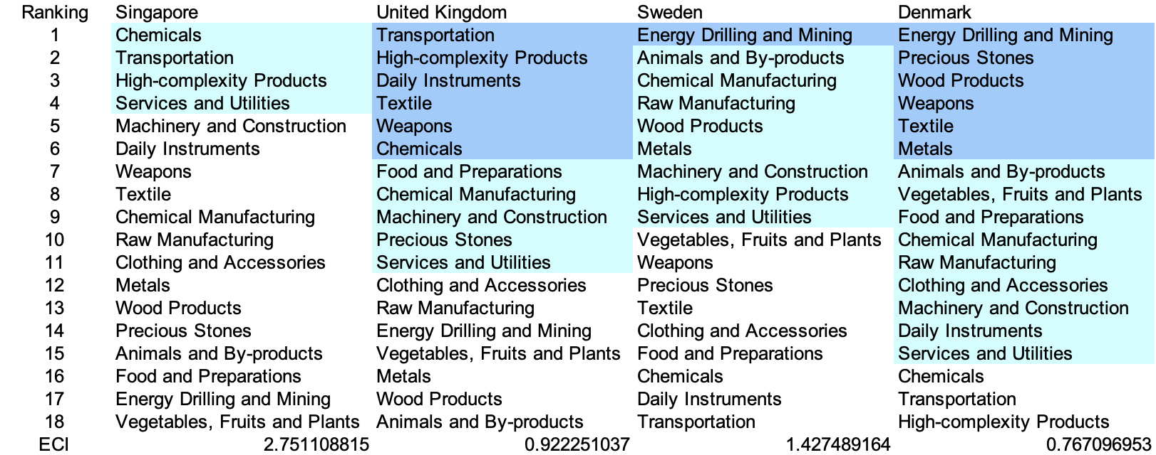
Table 5a. Opportunity Gain Ranking on a Comparable Scale (2013)

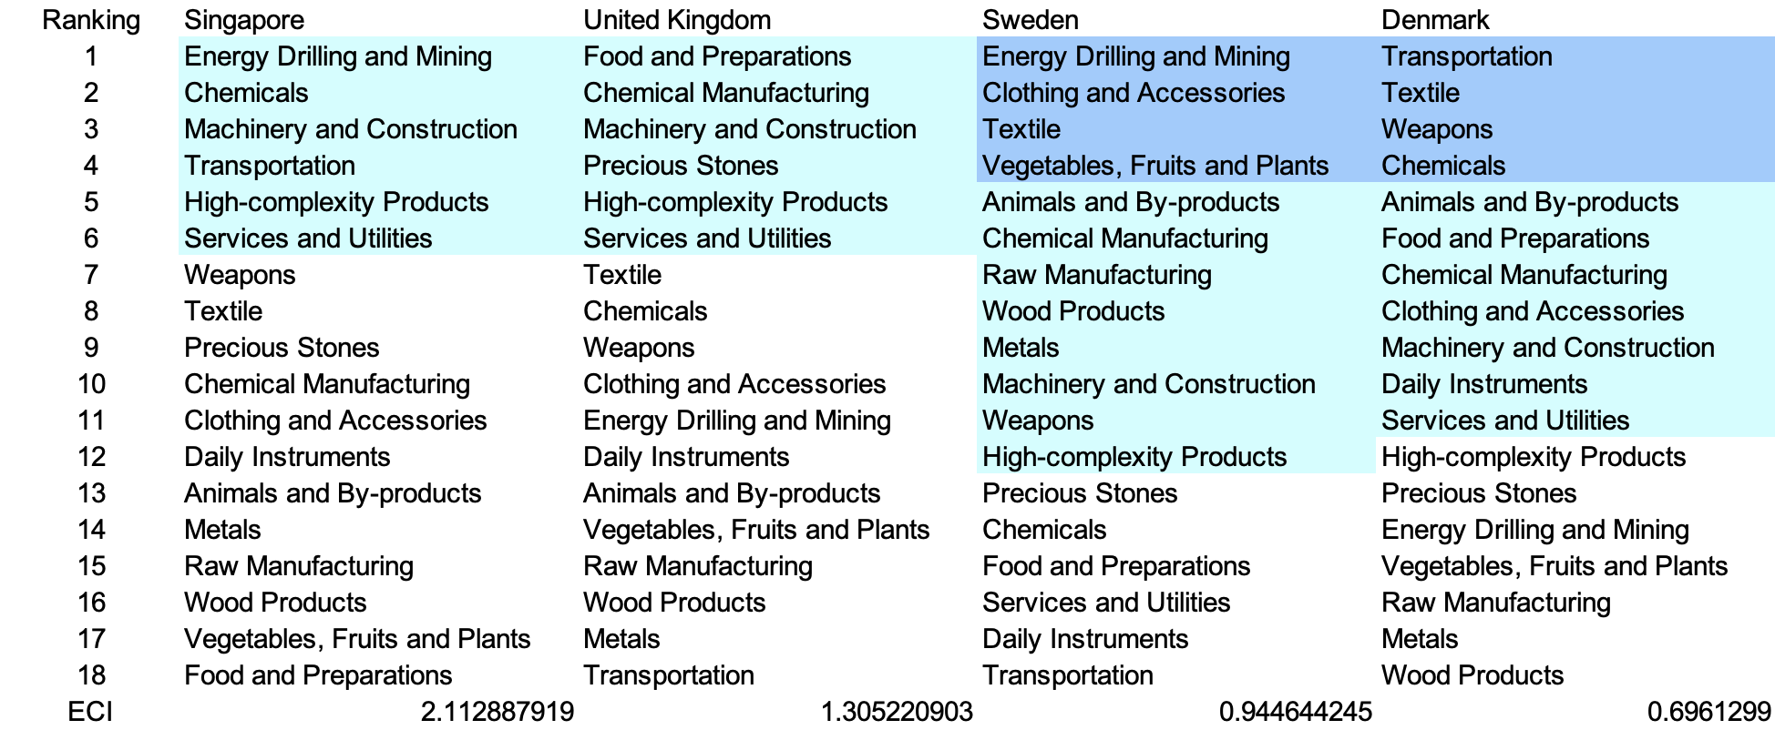
Table 5b. Opportunity Gain Ranking on a Comparable Scale (2018)
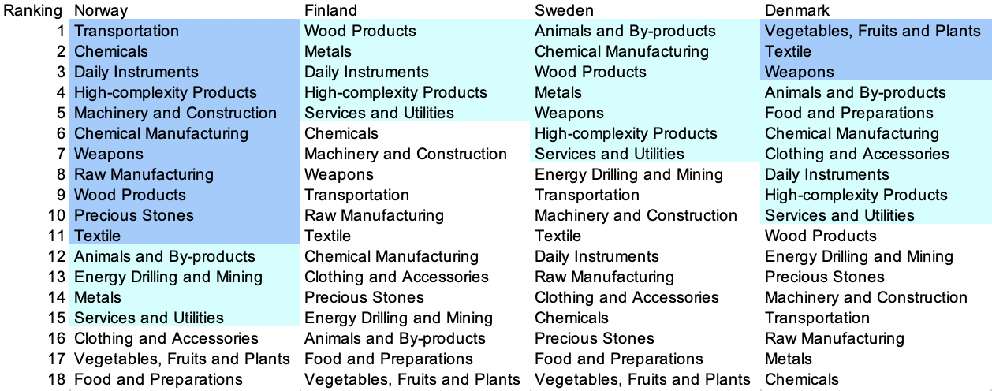
Table 5c. Opportunity Gain Ranking on a Comparable Scale (2021)

We define the ranking of opportunity gain for a country c, as the Suggested Development Vector (SDV) of c. Tables 5a-5c summarize how the SDV of Denmark compares with a selected group of regional and leading economies in the world, with the industry groups ranked in decreasing order of significance. We focus on SDV results for 2018 because they give the most accurate snapshot of complexity for global comparison in the absence of the irregular effects of the COVID-19 pandemic observed in 2021.

Dark blue indicates positive opportunity gain, light blue indicates zero opportunity gains, and white indicates negative opportunity gains. The result shows that leading countries barely have any industries with positive opportunity gain. In other words, those countries are already in the most stable and efficient economic structure. Without the necessity of economic transition, those countries merely need to maintain a steady and balanced economic development. In contrast, less developed countries have nearly half of industries with positive opportunity gain, and share common interests in industrial manufacturing and High-complexity Products industries. It can be concluded that Denmark shares the characters of a less developed country as compared with the world’s leading economies and other major economies in Europe, with a premature economics structure that leans towards basic to intermediate level industries.



Table 6: SDV of Other Typical Countries 2013
4.2 Budgeted Industry Development Strategy and Interpretation

The optimal budgeted industry development strategy aims to solve the most efficient allocations under the budgeted constraint of different situations of heuristic total export growth. In order to obtain such an allocation portfolio, we formulate an optimization problem as the following:



where k(x) is the second largest eigenvector of $M_{CC'}$ after adding $x$ to the original export vector, C is the country that we are interested in, P is the product space, B is the heuristic budget.

If we can solve this problem, then we can know what the largest ECI that a country can improve to. Accordingly, the optimal solution $x*$ that we obtain here is exactly our optimal allocation. However, the biggest problem is that the objective function is not convex. Therefore, we cannot apply the classical tools for convex optimization on this problem. In order to solve this problem, our idea is to use greedy algorithm. The way that we apply greedy algorithm is that firstly we separate the total budget into k equal parts, and then for the first equal part we try to search for the product that can optimize our objective function by iterating through each $p∈P$. After we find the optimal product p for this equal part, we add the amount back to the export value of this product p and update the ECI for this country. If we observe that ECI does not change after iterating all the products, then we can add up one more equal part to invest. Until we find there is an ECI increment, we add the amount now to that product. The rest equal parts can be done in the same way.

However, as is known to all, greedy algorithm is a kind of local search algorithm, which is pretty possible to run into a local minimum. Therefore, for local search algorithms, one typical way is to keep it away from the local minimum is to enhance the vision of the algorithm by looking more steps forward. In our setting, whenever we obtain an increment of ECI, we mark down the required amount of export growth. Simultaneously, we continue searching for the next ECI increment point, compare the ratios of these two possibilities and pick the largest one. The ratio is defined as the following:


where ${ECI}_{p}$ is just the ECI of the country after adding some amount of export increment to product $p$, which is exactly the amount that is able to make ECI change. Also, we can express it in the way of $||$$x_{p}-x_{0}$${||}_{1}$.

In this way, we can obtain a further sighted greedy algorithm. Also, the number of parts that we would like to separate the budget into also matters. In order to solve this problem, we added a stabilizer on top of the enhanced greedy algorithm, by running the algorithm for different numbers of parts and selecting the portfolio with the largest ECI increment and most complex economic structure.

Besides, it is quite common that there is a surplus for the budget. To deal with the surplus, we just add it to the product which needs the least amount of dollar to make $M_{cp}$ = 1, (i.e., the smallest amount of required export increase).

Interpretation:

For the purpose of a clear explanation of the line charts, we try to label all the products in Table 7. Please refer to this table when trying to understand the investment trajectories in the line charts.

Label | Product Names
1 | Animal and By-products
2 | Vegetables, Fruits and Plants
3 | Food and Preparations
4 | Energy Drilling and Mining
5 | Chemicals
6 | Chemical Manufacturing
7 | Raw Manufacturing
8 | Wood Products
9 | Clothing and Accessories
10 | Textile
11 | Metals
12 | Machinery and Construction
13 | Transportation
14 | Weapons
15 | Daily Instruments
16 | Precious Stones
17 | High-complexity Products
18 | Services and Utilities
Table 7. Products Labeling

Figures 4a-4c show an economic panel for Denmark in 2013, 2018, and 2021. We can see that for different percentages of heuristic total export growth, the ECIs of Denmark actually have different increments.

For 2013, overall, with a 5 percent growth in export, the ECI of Denmark starts growing from around 0.77 and ends at around 1.04. However, with a much larger amount of budget, such as 10, 15, and 20 percent growth, Denmark’s ECI can actually achieve a much higher level, namely around 1.50.

For the case of 5 percent growth in export, services and utilities, chemicals are main components of the portfolio. For the case of 10, 15 and 20 percent increment budgets, we realize that the development trajectories are in a similar pattern, mainly consisting of vegetables, fruits, and plants and high-complexity products. Similar to other developed countries, Denmark also has a relatively sparse solution, which can be reasoned by its pretty well-rounded economic structure. However, from the ECI improvement trajectories, we observe that most of the increments are resulted by high-complexity products, meaning that increasing investment in the development of high-complexity products can help improve the economic complexity structure of the country to a great extent. Additionally, Denmark can also focus on the development of vegetables, fruits, and plants, which can be beneficial for the production of other industries.

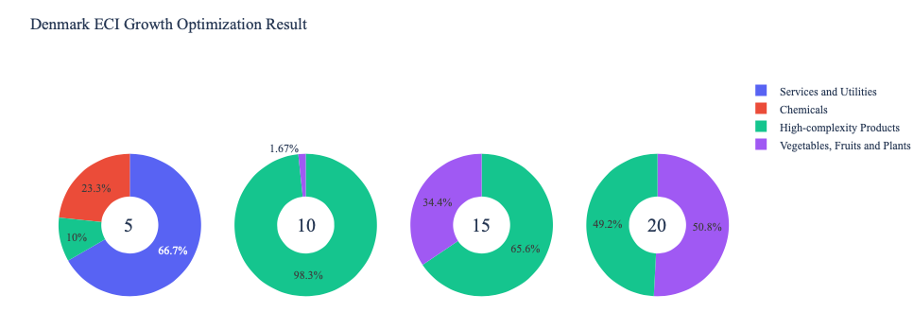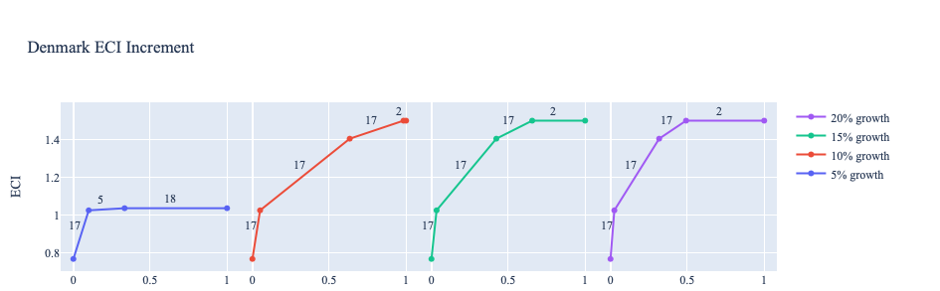
Figure 8a. Greedy-Based ECI Improvement Results of Denmark with Different Budgets (2013)

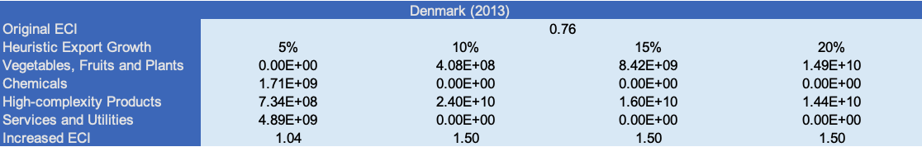
Table 8a. Portfolio of Denmark (2013)

For further suggestions on Denmark’s development in the future. We also offer the optimization result based on export data in 2018. Below is the economic panel for Denmark in 2018. We can see that there is a similar pattern for the ECI improvement trajectories, which is that the improvements in 10, 15 and 20 percent export growth are similar, and all of them are greater than the one in 5 percent growth. Again, since Denmark is a pretty developed economic entity, the optimization result is very sparse and there are not so many suggestions for future development in terms of ECI improvement. With 5 percent growth in export, vegetables, fruits, and plants remains as the main component for ECI improvement, but as the budgets become larger, it becomes less important or even replaced by transportation and high-complexity products. A more detailed numerical representation of the portfolio is shown in Table 9.

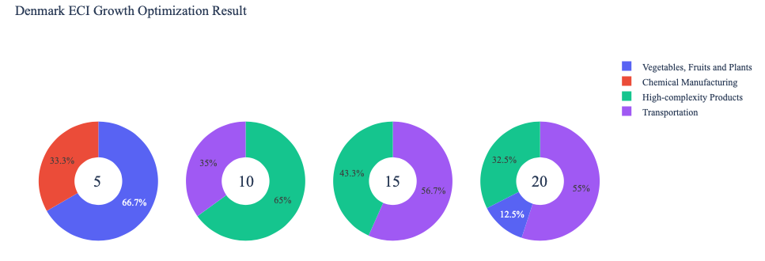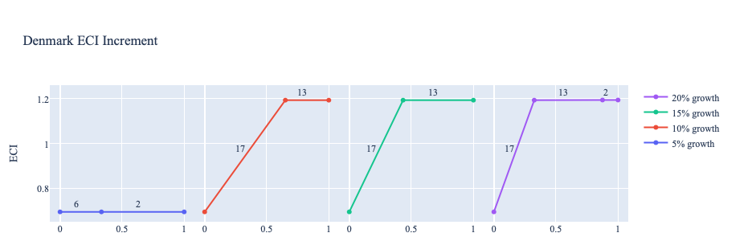

Figure 4b. Greedy-Based ECI Improvement Results of Denmark with Different Budgets (2018)

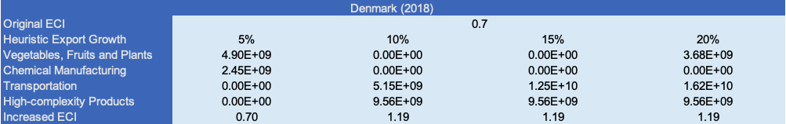
Table 8b. Portfolio of Denmark (2018)

To compare with the performance in 2013 and 2018, we also re-examine suggested strategies for 2021. For 2021, a 5 percent increase in export would emphasize Precious Stones, followed by Transportation for 10% and 15% and Animal and By-products for 20% export growth. These strategies go in line with the suggested trajectories based on ECI. Interestingly, the recommended post-pandemic economic response is to invest heavily in lower complexity sectors. This can be interpreted as the need to reinforce the fundamental industries as a result of supply chain and global trade disruptions. A more detailed numerical representation of the portfolio for Denmark is shown in Table 8c.

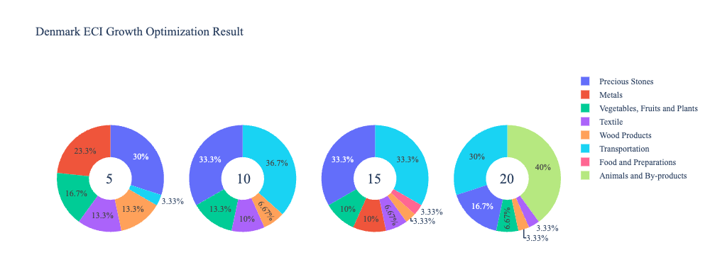
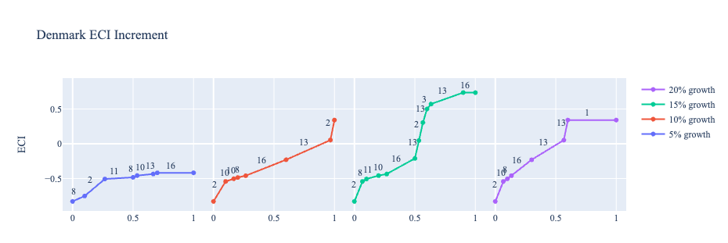
Figure 8c. Greedy-Based ECI Improvement Results of Denmark with Different Budgets (2021)

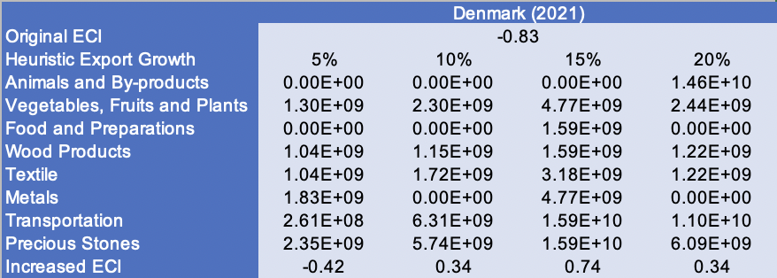
Table 8c. Portfolio of Denmark (2021)
4.3 Sensitivity Analysis and Contingency Strategy
In the following section our broad aim is to understand how sensitive Denmark is to changes in export in various industries. While the Economic Complexity Index has been shown to contain valuable information about the economic strength/capacity of a country, little has been said as to the stability of the measure itself. We seek to uncover the main drivers of stability under a country's ECI score and better understand longer-term projections for ECI growth. Additionally, gaining an intuition on the industries that are bolstering an economy and the industries that offer the greatest return per unit of investment is best done through visualization of industry specific sensitivity. To this end, we have developed two categories of sensitivity analysis.
ECI Sensitivity Graph
Firstly, in order to assess the effect particular industries have on each respective country, we developed ECI Sensitivity graphs. We use shocking methodology to increment or decrement an industry’s export level by a certain percentage and recalculate the ECI all else being equal. While freezing the export dynamics of the rest of the world and enacting an instantaneous shock in export for a particular industry and country may not reflect real-life dynamics, what it does offer us is an understanding of a country’s level of dependency on an industry in the context of ECI. The shocking is done in small percentage increments in order to smooth out the resulting curve. Additionally, a recurring theme one will see is that for most industries, a breaking point occurs where the ECI either jumps upwards or downwards, creating a hockey stick shape rather than a linear trend. While the inflection point may not be accurate in context of real life, comparing the various inflection points across industries can give us valuable insight.
The graphs are formulated as follows: There are four ECI Sensitivity graphs. The first two represent data from 2018. The first chart shows positive shocking in which export numbers are shocked upwards per industry. The X-axis is in terms of percentage shock per current dollar value of export. The Y-axis is the recalculated ECI level post-shocking. The second chart follows the same format except the X-axis represents negative shocking. In other words, exports for each industry are decremented and the ECI is accordingly recomputed. The final two sensitivity graphs show the same results using 2013 data. Below is an example of an ECI sensitivity graph.

Example 2018 (Incremental ECI Sensitivity)

SDV sensitivity
Secondly, we analyze the sensitivity of the SDV to changes in export levels. The goal is to understand how export level changes for a particular industry can affect the marginal opportunity gain for other industries. We will be using specifically High Complexity Products and Food and Preparations as our base industries. We will be increasing or decreasing the absolute export level in both of these industries and observing the effects on the SDV.
When the opportunity gain of an industry is negative, the SDV sensitivity approximates how an over-development of the industry jeopardizes the economic structure of a country. When the opportunity gain of the industry is zero, the SDV sensitivity determines whether the further development of the industry shapes the country with a better economic structure and predicts how the SDV would change accordingly. Specifically, as we reduce the export of such an industry to 25%-50% of its original value, a few other industries originally with negative opportunity gain could likely become profitable.
Similar to the ECI sensitivity graphs above, we will be shocking export of High Complexity Products and Food and Preparations in small percentage increments. A new SDV, represented by a new column in the charts, is recorded only when a certain level of shock changes the structure of the SDV. In effect we are incrementing or decrementing export levels of two industries until the marginal opportunity gain of any industry changes in category (positive, negative, or neutral). Below is an example of a SDV Sensitivity chart with Positive Shocking. Industries with positive marginal opportunity gain are colored blue, neutral is colored white and negative is colored red.


Example High-complexity Products 2018 (Incremental SDV Sensitivity)

4.3 Sensitivity Analysis Results and Interpretation
We examine Denmark’s ECI Decremental and Incremental Sensitivity Charts for 2021. An increase in High-Complexity Products will lead to the highest change in ECI, followed by Transportation and Chemicals. The strong sensitivity effect of manipulating the High-Complexity Products and Transportation category remains consistent with previous years. For the negative shock cases, Food and Preparations becomes most impactful, consistent with past years which suggest that decreases in the export would lead to an increase in ECI.
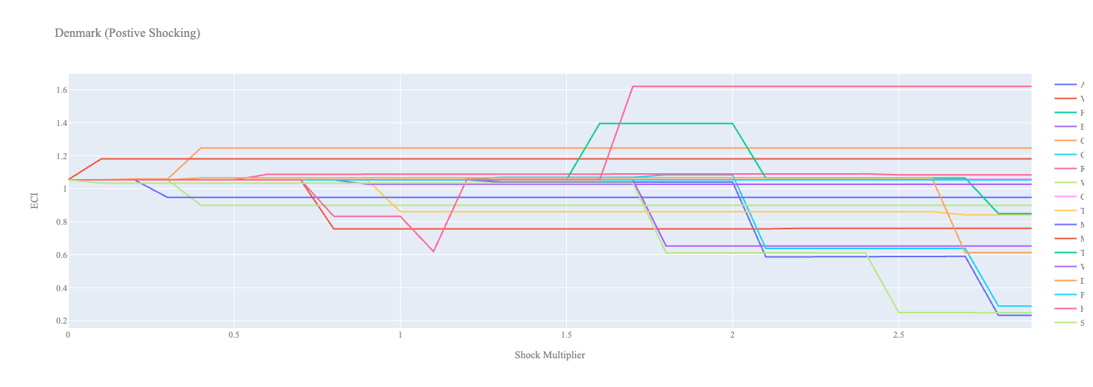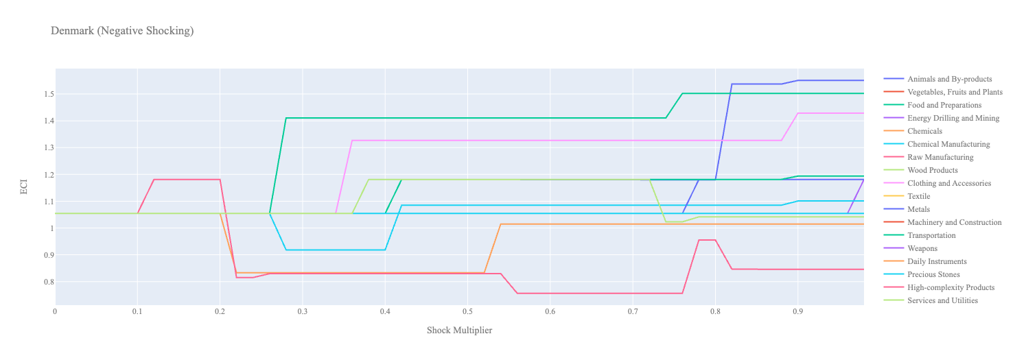
Figure 6a. Incremental ECI Sensitivity for Denmark (2021)
Figure 6b. Decremental ECI Sensitivity for Denmark (2021)

Below is Denmark’s 2018 ECI Sensitivity Charts. Firstly in the positive chart, we notice immediately that increases in High Complexity Product, Transportation lead to higher ECI scores. In general Denmark is slightly prone to small decreases in ECI with increases in all other industries.

Next we consider Denmark’s 2018 Negative Shock chart. Immediately we see that decreases in the export of Food and Preparations, as well as Clothing and Accessories could be quite beneficial for Denmark’s ECI score. Also of note is that Denmark is very sensitive to drawdowns in Machinery, which can bring the ECI near zero with less than a 20% drawdown.
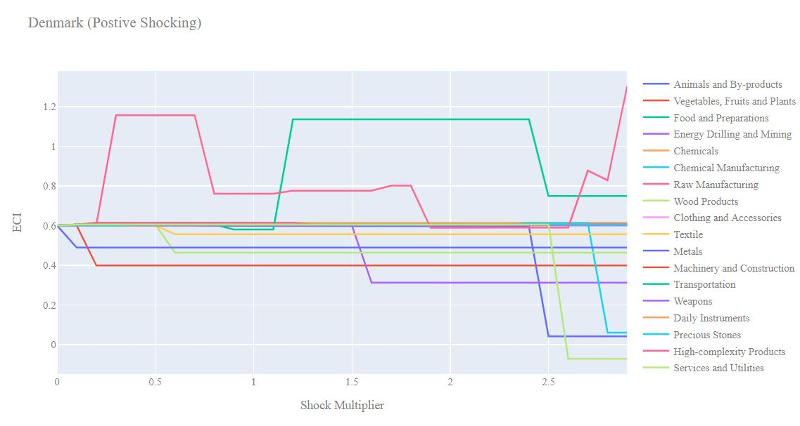
Denmark 2018 (Incremental ECI Sensitivity)

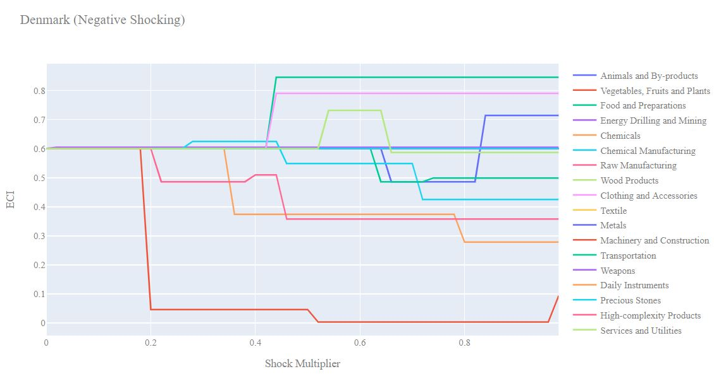
Denmark 2018 (Decremental ECI Sensitivity)

Next we consider the 2013 ECI Sensitivity graphs. We see that in the positive shocking case, the landscape of ECI sensitivity has not altered significantly over the five year period. High complexity products and Transportation seem to offer slight increases in ECI. Again, increases in export in all other industries lead to slight decreases in ECI score.

In the 2013 negative shocking case, we see that again Denmark is very sensitive to drawdowns in Machinery. Additionally we see that decrease in exposure to Vegetables, Fruits and Plants seem to offer an immediate increase in ECI score.

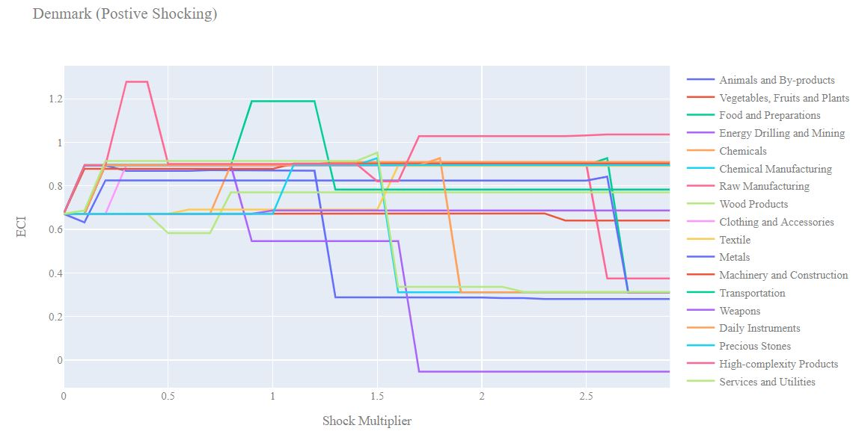
Denmark 2013 (Incremental ECI Sensitivity)

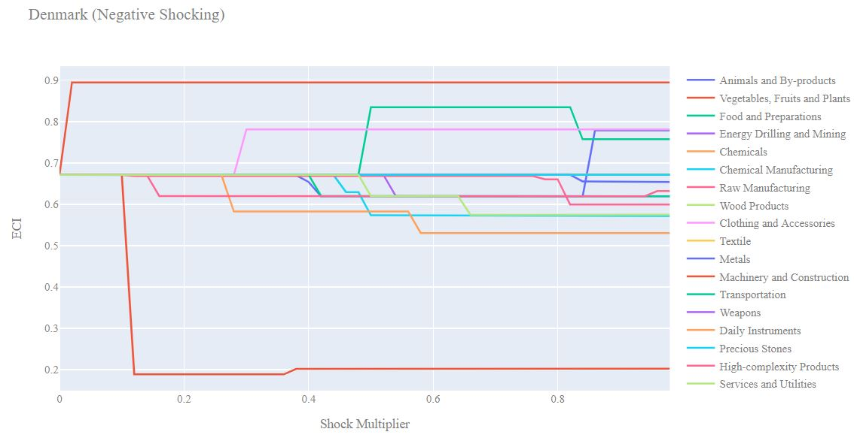
Denmark 2013 (Decremental ECI Sensitivity)

Below we see the SDV sensitivity charts for High Complexity Products. Denmark’s SDV is quite sensitive to changes in High Complexity products and we see that a similar mix of industries have positive opportunity gain as we increase the export of High Complexity Products. Decreasing the export of High Complexity products leads to a very similar composition of positive opportunities for Denmark.

Denmark’s SDV seems to be generally insensitive to changes in export of Food and Preparations suggesting that this is not a key industry for the country.

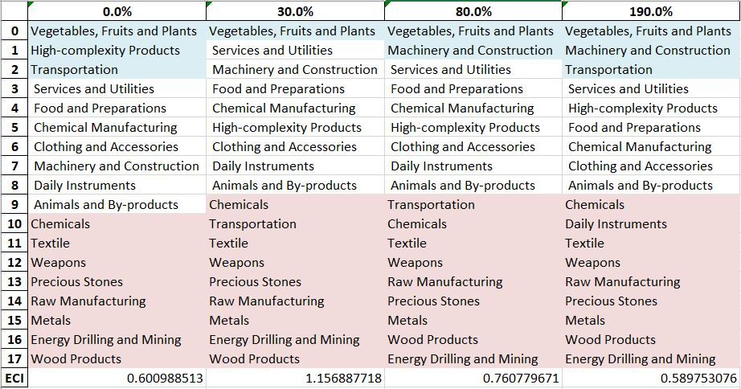
Denmark High-complexity Products 2018 (Incremental SDV Sensitivity)

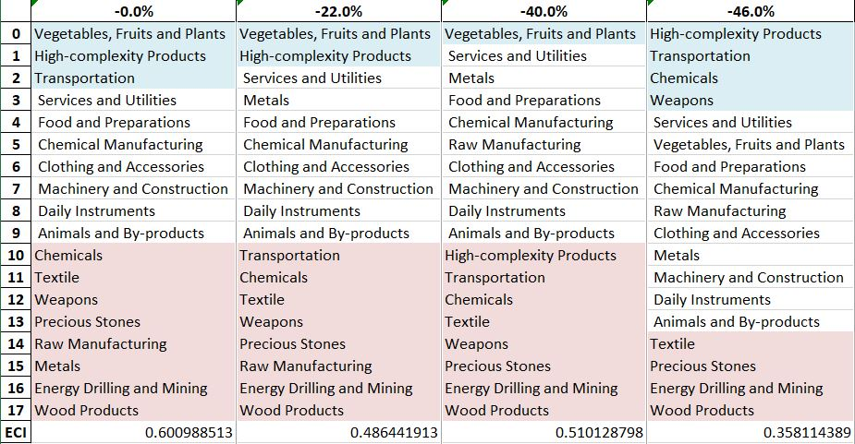

Denmark High-complexity Products 2018 (Decremental SDV Sensitivity)

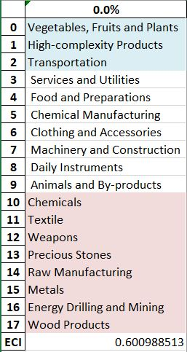
Denmark Food and Preparations 2018 (Incremental SDV Sensitivity)

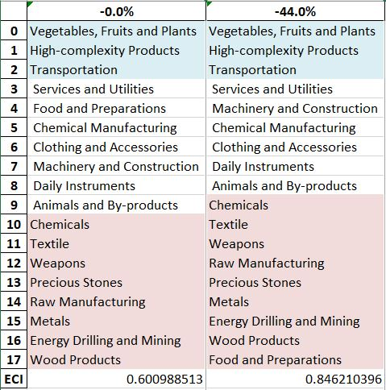
Denmark Food and Preparations 2018 (Decremental SDV Sensitivity)

4.4 Contingency Strategy

Decreasing export of each industry in Denmark’s current production space by 60% respectively, we derive the contingency strategy shown below.

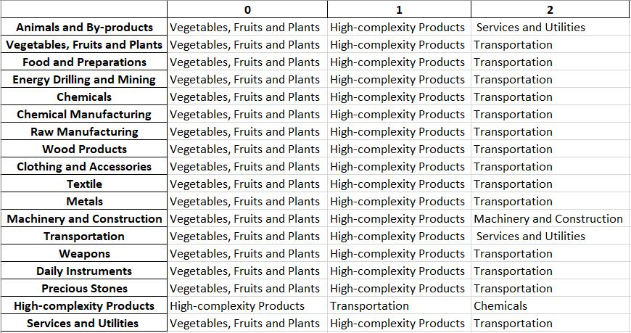
Denmark Contingency Strategy 2018

5. Macro-level Predictions

5.1 Structural Optimality Index
Indeed, such choice of prioritization has proven to be a significant factor in deciding the economic outcomes of countries. In order to quantitatively evaluate how effective our development strategies are and how deviations from the suggested developmental path will lead to suboptimal growth results, we define the measure – Structural Optimality Index (SOI) – on a country level as the Adjusted R-Square obtained from regressing the country’s realized industry development over the suggested development strategy. Both strategies are quantified in nature, with the realized development represented by export increase in every major industry group and the suggested development strategy represented by the opportunity gains of developing the corresponding industry groups as calculated in previous sections. The adjusted R-square from the regression thus provides us with a quantified measure of how the development path adopted by the country has fitted with/differed from calculations on a complexity level.

After obtaining this measure for all countries in our database, we further regress countries’ five-year economic growth, which is defined as the percent increase in GDP (USD), over their SOI. Figure 6 illustrates the regression output, which shows a strong positive correlation between countries’ SOI and their five-year GDP growth, significant at the 1% level and achieving an adjusted R² of 4.5%. In other words, the more a country develops as suggested by calculations on a complexity level, the better economic outcomes it achieves.

Table 18: OLS Regression Results
Dep. Variable: GDP | F-Statistic: 5.963
R²: 0.054 | Prob (F-Stat): 0.0163
Adj R²: 0.045 | No. Observations: 106

Figure 9. Regression of Five-Year GDP Growth over SOI (2013-2018)

5.2 SOI of Denmark and Its Implications
Denmark, for instance, has an average level of structural optimality as compared with its developed peers. As the regression in Figure 10a suggests (the orange curve represents export increase and the blue curve stands for opportunity gain of the corresponding industry), Denmark demonstrates a lower level of correlation with the suggested developmental path, having an adjusted R-square of around 4.8%. Denmark ranks in the second quartile among all countries in terms of SOI and has made an average rate of economic progress among its emerging peers from 2013 to 2018 with a 5-year GDP growth rate of 23.3%, which is consistent with the regression result in Figure 6. This is in direct contrast to emerging economies such as Turkey, where there is high SOI of around 21.8% and a corresponding GDP growth of 36.7% from 2013 to 2018, making it one of the fastest developing economies during the period. In sum, Denmark’s relatively slow economic progress from 2013 to 2018 can be at least partially explained by a development strategy that slightly deviated from our suggested developmental path. In specific, Denmark invested heavily in the Services and Utilities industry, while it should have focused more on industry groups such as Energy Drilling/Mining and Precious Stones.

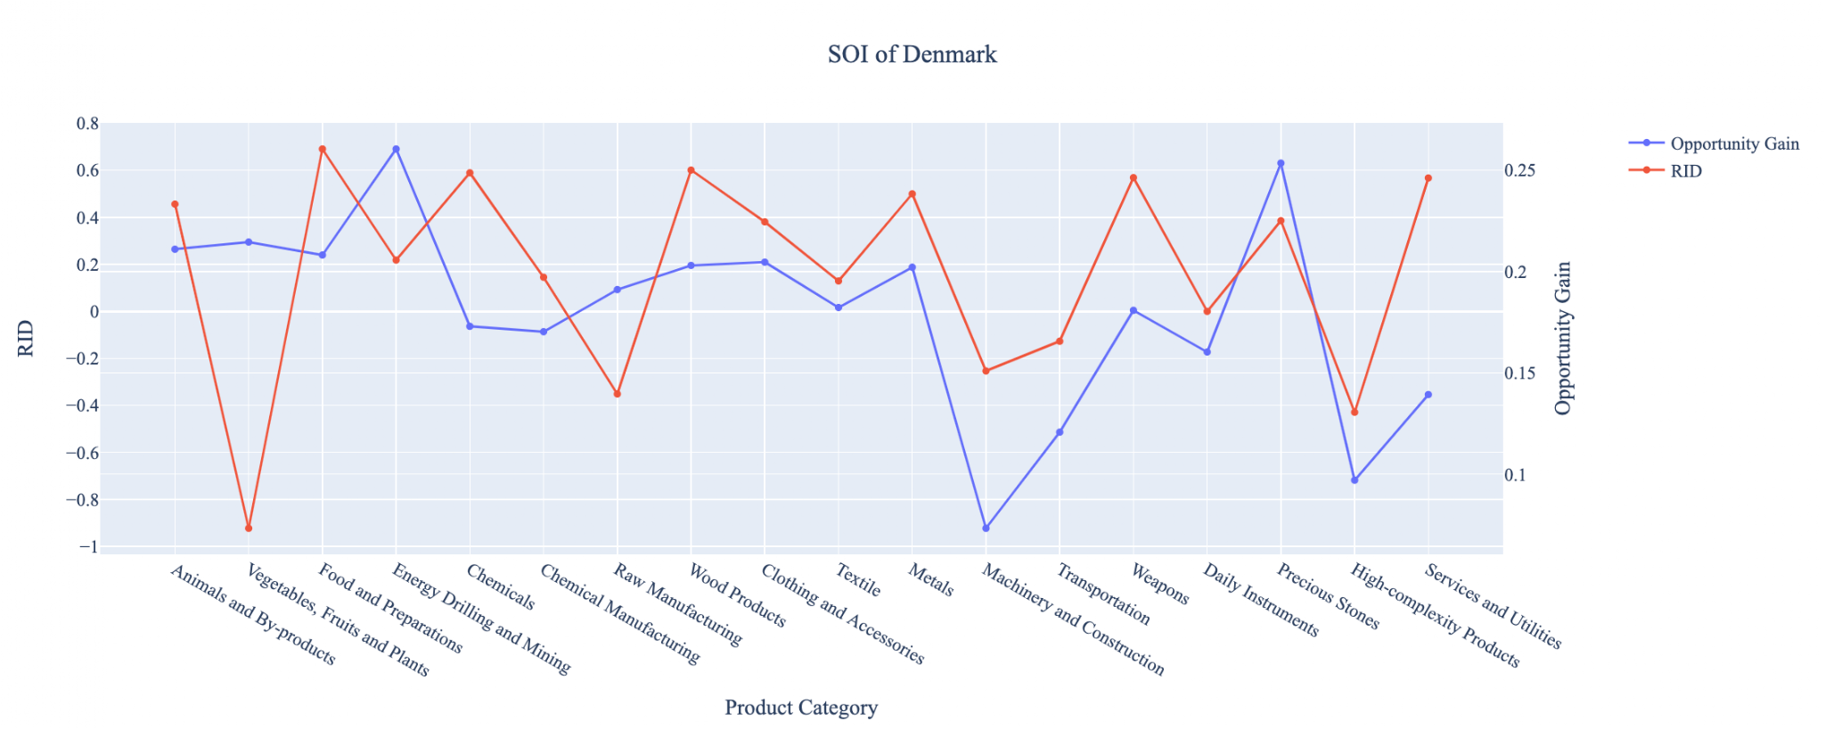
Figure 10a. SOI of Denmark (2013-2018)

For the 2019-2021 years, Denmark has a strong presence in the Chemical Manufacturing and High-Complexity Products industries, which they seem to be overdeveloped when considering their lower opportunity gain relative to RID. It also could consider Energy, Drilling, and Mining to improve its growth. Denmark has seen a slower growth in GDP over those three years at 4.66%, compared to 23.3% for the average yearly growth for the five years prior.

Lower than before, its adjusted R-squared value of 2.4% still indicates a low correlation between the GDP growth and the implemented development path. Progress is slow on a global scale during this period, but Denmark demonstrates a lower ability to adjust to negative economic shocks by improving SOI and increasing GDP growth than it did between 2013 and 2018.

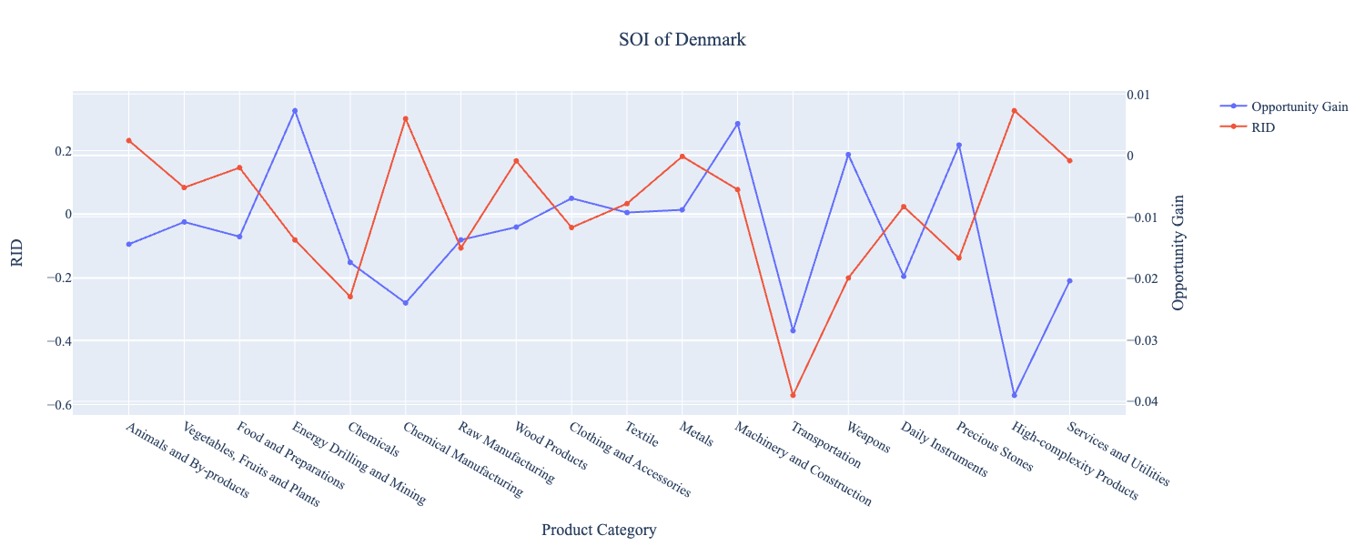
Figure 10b. SOI of Denmark (2019-2021)

6. Concluding Remarks

In conclusion, Denmark has demonstrated a moderate level of economic growth in terms of annual GDP increase during the period from 2013 to 2018, concurrent with a decrease in economic complexity as compared with other developed economies. For 2019-2021, the growth in GDP has slowed alongside a large decrease in ECI, in line with its comparable countries.

The lack of progress during the period, we believe, can be partially explained through analysis of the economic and product complexity structure of Denmark on the industry group level. The product classification system we adopt allows us to measure the realized industry development for various industry groups and to observe that Denmark consistently relied on developing the Food and Preparations, Wood Products, and Chemicals industries in 2013-2018, while its developed counterparts and emerging economies around the globe adopted much more complex and progressive paths.

Based on our analysis of the opportunity gain and a sensitivity analysis of major industry groups, Denmark can further its gains by prioritizing High-Complexity Products and Transportation. We further note that Denmark has a slightly mismatched development strategy that indicates an average (compared to other developed economies) level of structural optimality on the complexity level, having an adjusted R-square of around 4.8%. Since a significant positive correlation exists between five-year GDP growth and the structural optimality index of an economy as we define and calculate, Denmark indeed has a suboptimal growth experience as compared with fast-growing economies both on a regional scale and on a global scale, and has the potential to further its economic gains through industrial structure optimization as suggested in the paper.

During the second examined period from 2019 to 2021, Denmark performed similarly to its comparable countries, particularly Sweden. We infer that during the COVID-19 period, Denmark focused on developing higher complexity industries despite a lower demand for these industries given the global economic downturn. We also note that Denmark has increased its investment in the sectors identified earlier, leading to a strong boost from High-Complexity Products industries, which remains an integral sector as demonstrated by the sensitivity analysis. The greedy approach suggests that greater growth could have been achieved through investments in Transportation, which is aligned to our recommendations from previous years. The slight decrease to the adjusted R-squared value to 2.4% in 2021 from 4.8% in 2018 demonstrates that Denmark has room for strategic improvement by investing in the industries mentioned above. With the revised focus, Denmark has further potential to advance its economic growth to maintain its position among other countries to continue its ongoing economic expansion.

References

Hausmann, R., Hidalgo, C., Bustos, S., Coscia, M., Chung, S., Jimenez, J., Simoes, A. and Yıldırım, M. (2007). The Atlas of Economic Complexity. [online] Atlas.cid.harvard.edu. Available at: http://atlas.cid.harvard.edu/.

Balassa, B., “The Purchasing Power Parity Doctrine - A Reapprais- al,” Journal of Political Economy 72, 584-596 (1964).

Feenstra, R.; Lipsey, R.; Deng, H.; Ma, A. & Mo, H. “World Trade Flows: 1962-2000” NBER working paper 11040. National Bureau of Economic Research, Cambridge MA (2005).

United Nations Commodity Trade Statistics Database (http://comtrade.un.org/db/), accessed in August 2019.

The World Economic Forum, “The global competitiveness report,” (various years).

Barro, R. & Lee, J-W. “A New Data Set of Educational Attainment in the World, 1950-2010,” NBER Working Paper No. 1590 (2010).

Kaufmann, D. & Kraay, A. “Governance Indicators: Where Are We, Where Should We Be Going?” Policy Research Working Paper 4370. Washington, DC: World Bank (2008).

Hanushek, E.A. & Woessmann, L. “The Role of Cognitive Skills in Economic Development,” Journal of Economic Literature 46(3), 607- 668 (2008).

